Atria Institute of Technology



**Department of Information Science and Engineering**

**Big Data Analytics (18CS72)**

**Assignment-1**

**SUBMITTED BY**

Name: Poorna Pragna G

USN:1AT20IS060

Section:7 ISE-2

Submission Date:05-12-2023

**Course Handling Faculty Name:**

Dr. K S Ananda Kumar

Associate Professor

Dept of ISE, Atria IT.

**Table of contents**

|  |  |
| --- | --- |
| **Sl. No** | **Description** |
| 1 | 1. create an **EC2 Linux** instance in AWS Cloud /Any cloud  INSTANCE NAME - **YOUR NAME**  INSTANCE TYPE - t2.micro/any other also.  key pair name- your name  storage - 10 GB  Take the screenshot of instance running status  Mention the private IP address and Public IP address.  (Execute this program/concept and take a screenshot of the output) |
| 2 | Execute the basic Linux commands/ simple program on the instance  (Execute this program and take a screenshot of the output) |
| 3 | Create the **GitHub** Account with your credentials, Same things stored in public repository in Github. Share the assignment in github link. |

**Note:**

1. Minimum 10 Screenshots with proper explanation
2. Minimum no of pages – 10
3. Submit your Assignment soft copy (Word & PDF) to [anandakumar.ks@atria.edu](mailto:anandakumar.ks@atria.edu).

**Subject Line in mail:** Student_Name_USN_BDA_Assignment1

1. Share your assignment Github link in Assignment Document.
2. Submit Assignment on or before **27th Nov 2023.**

**Instance Creation-01**

/List the steps with proper explanation & Screenshots/

/Any number of pages/

* Sign in to the AWS Management Console:
* Go to the AWS Management Console (https://aws.amazon.com/).
* Sign in with your AWS account credentials.
* Navigate to EC2:
* In the AWS Management Console, navigate to the "EC2" service.
* Launch Instance:
* Click on the "Instances" link in the EC2 Dashboard.
* Click the "Launch Instance" button.
* Choose an Amazon Machine Image (AMI):
* Select an AMI from the list. This is the operating system for your instance.
* Choose an Instance Type:
* Select an instance type based on your requirements. The types differ in terms of CPU, memory, storage, and networking capacity.
* Configure Instance:
* Set the number of instances to launch.
* Configure other instance details like network settings, subnet, auto-assign public IP, etc.
* Add Storage:
* Specify the amount of storage for your instance.
* Add Tags:
* Add tags to your instance for better organization. Tags are key-value pairs.
* Configure Security Group:
* Create a new security group or select an existing one. This controls inbound and outbound traffic to your instance.
* Review and Launch:
* Review your configuration settings.
* Click the "Launch" button.
* Create Key Pair:
* If you don't have a key pair, you'll be prompted to create one. This is used to securely connect to your instance.
* Launch Instances:
* Click "Launch Instances" to create your EC2 instance.

**SCREENSHOTS**

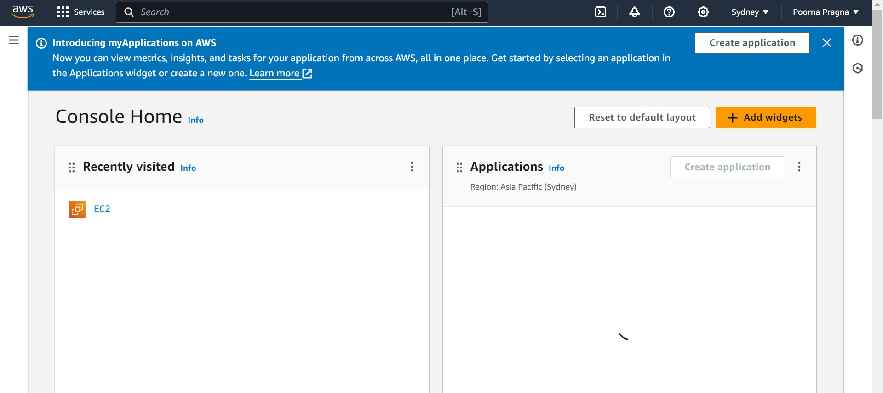

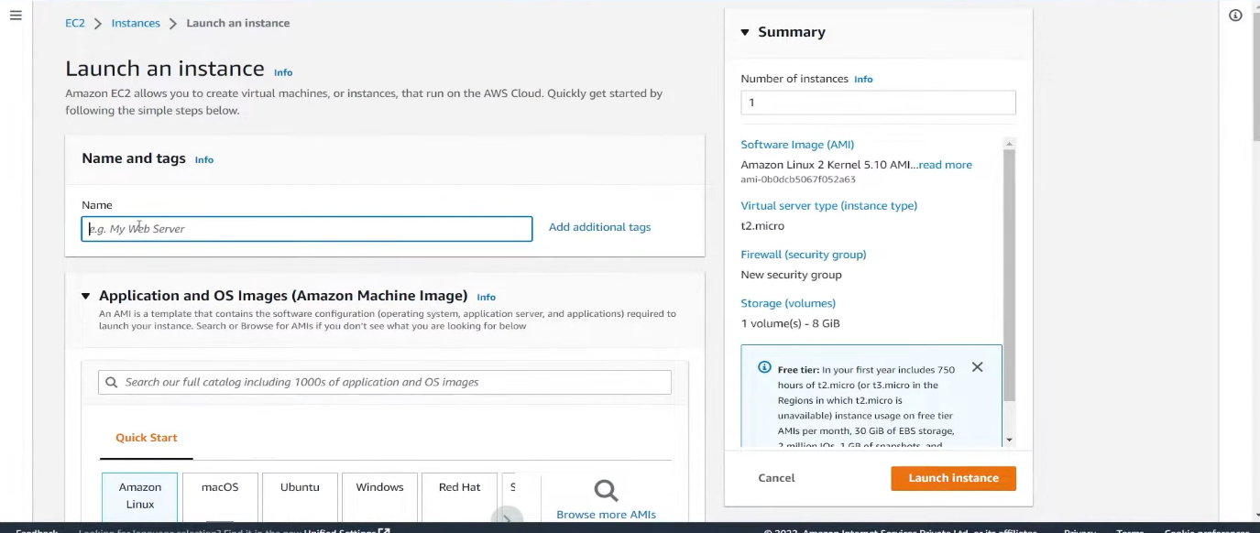

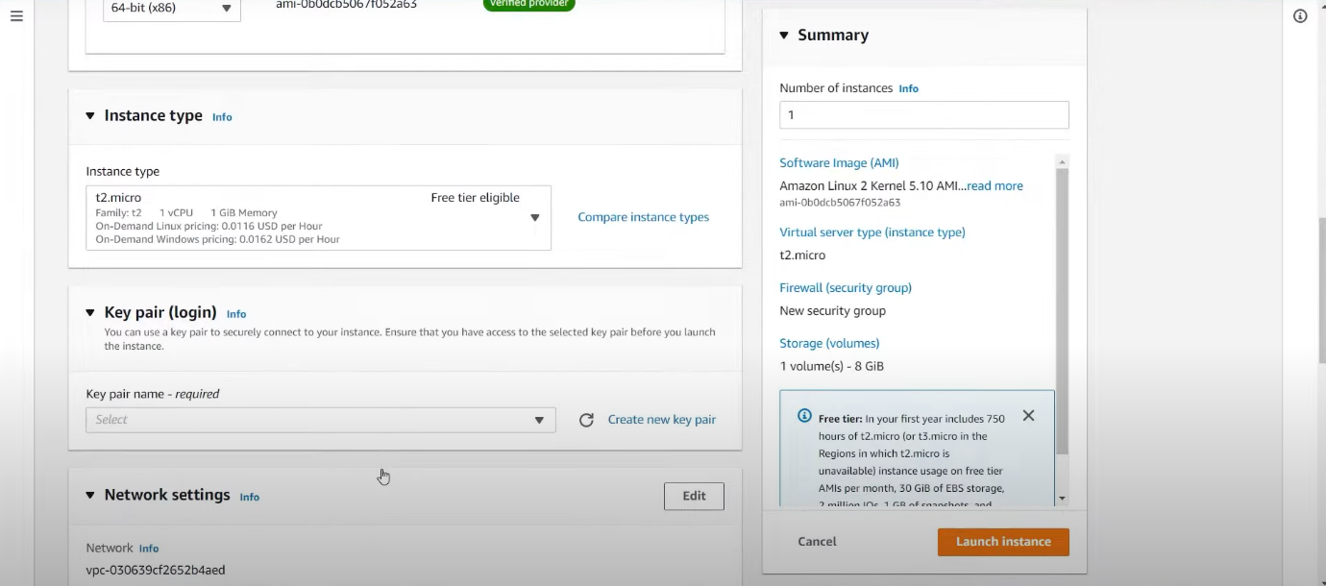

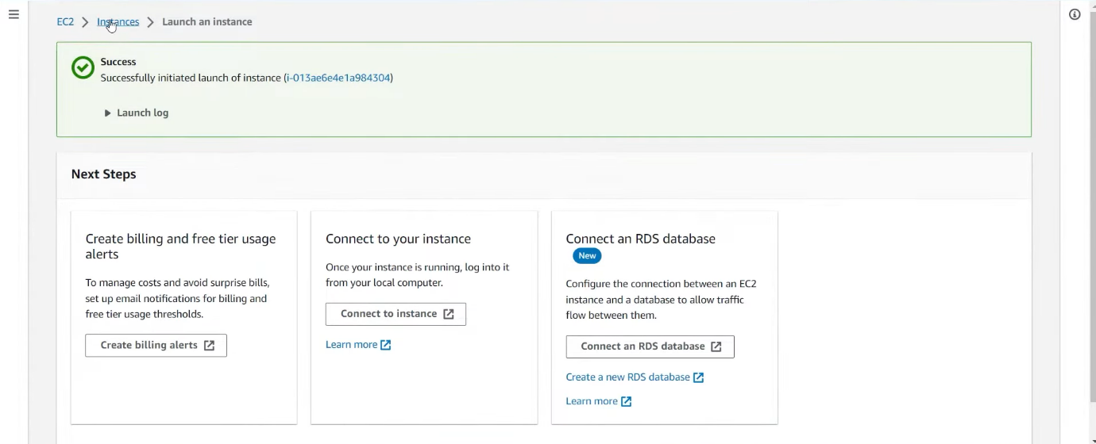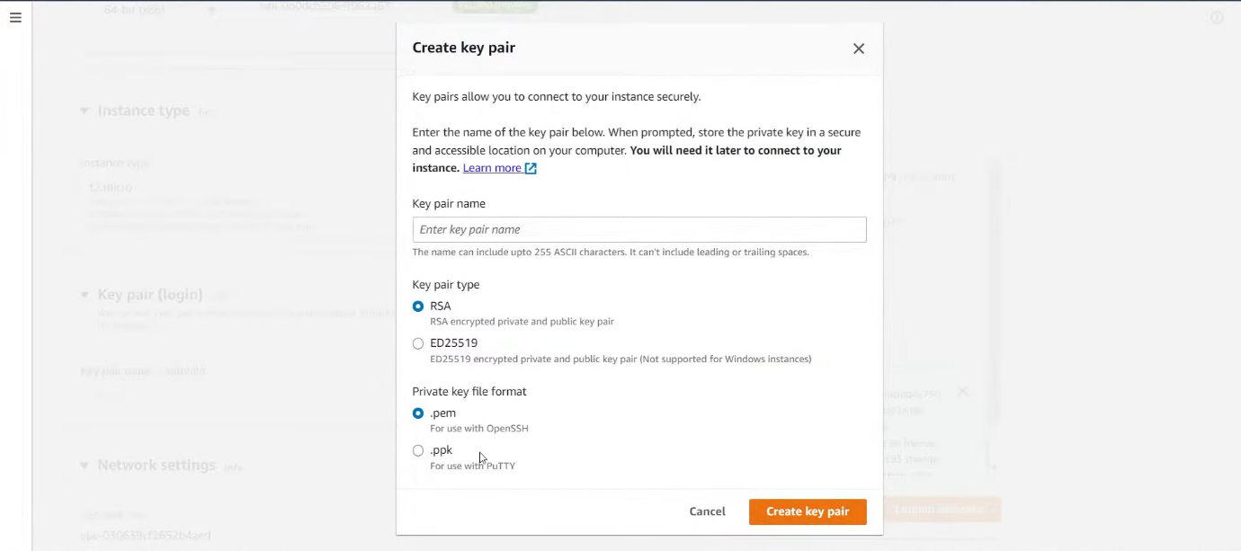

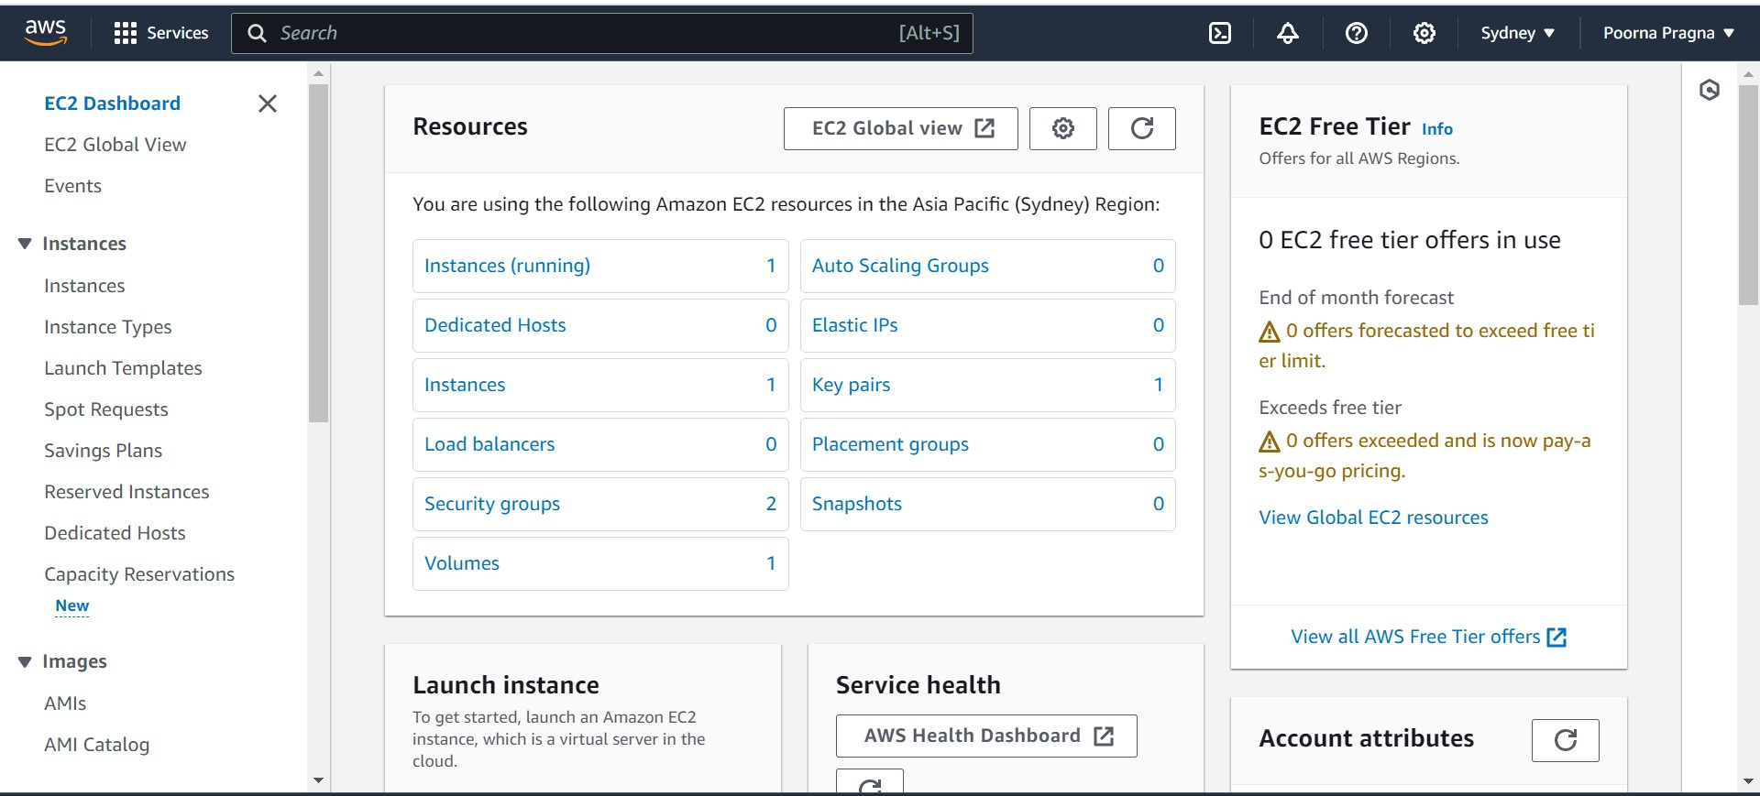

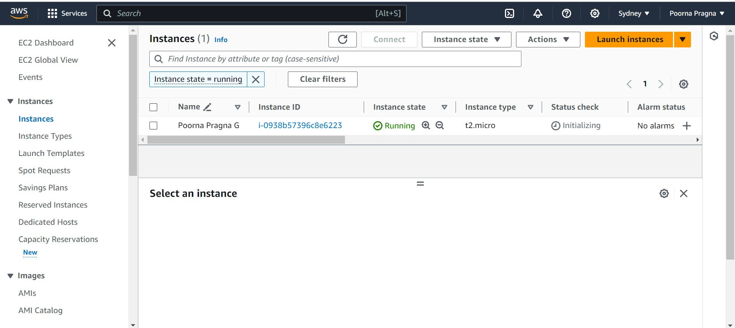

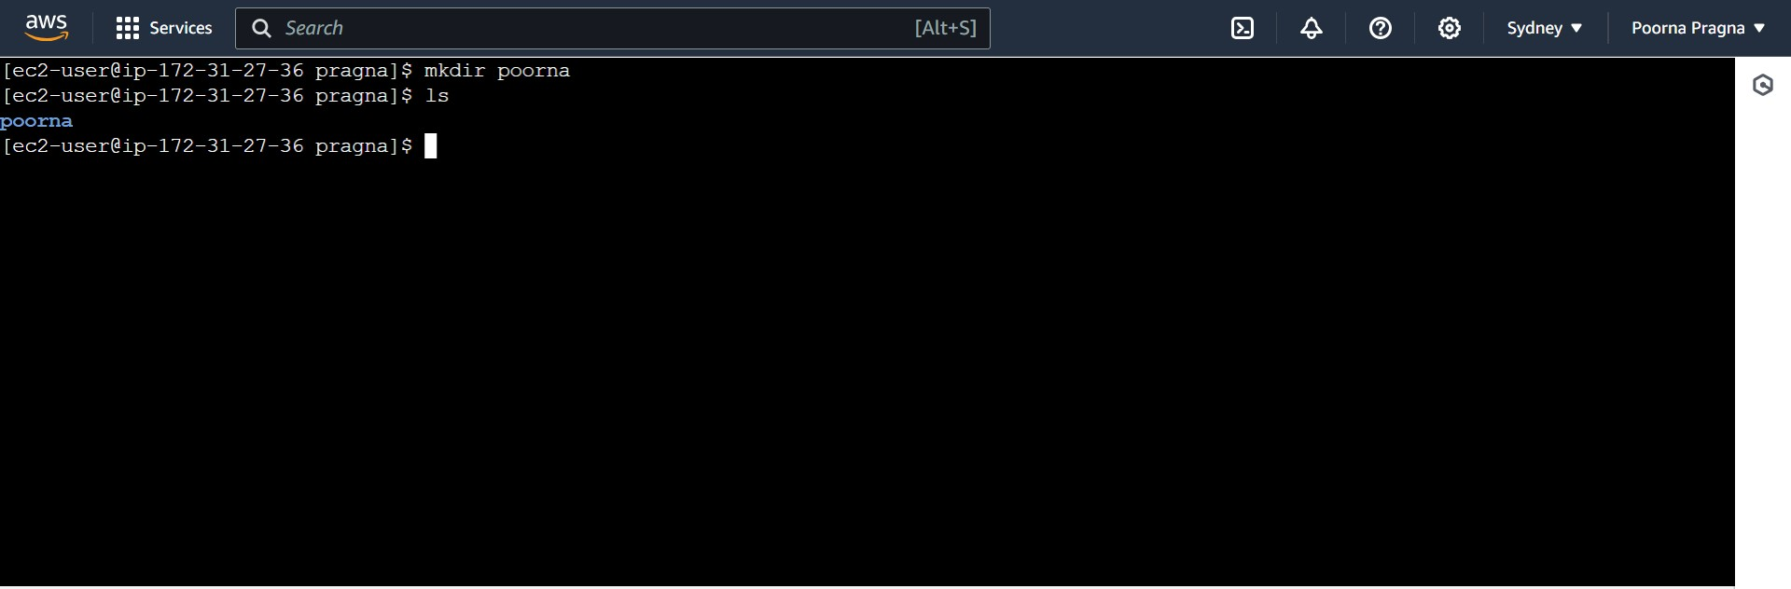

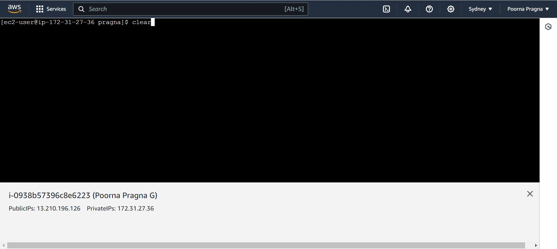

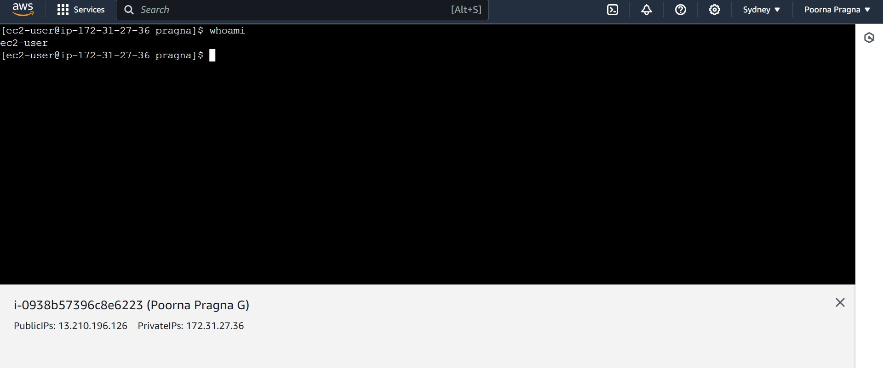

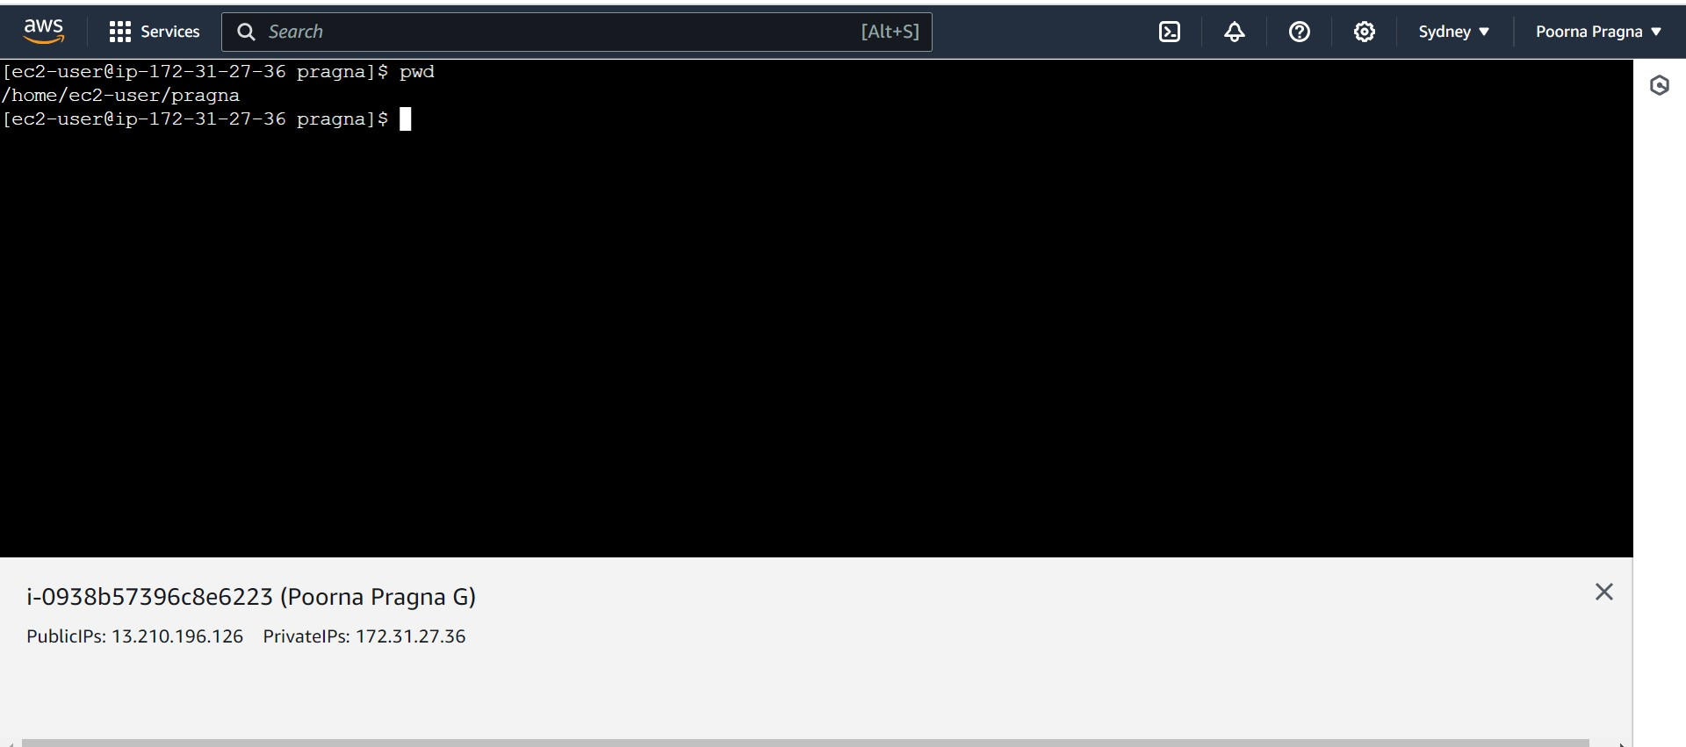



**Running sample Program on Linux Instance**

1. mkdir: This **mkdir command** allows you to create fresh directories in the terminal itself. The default syntax is mkdir <directory name> and the new directory would be created within the current directory.
2. **Clear:** The clear command in Linux is used to clear the terminal screen. When you execute the clear command, it removes all the previous commands and their output from the terminal, giving you a clean slate
3. Whoami: The clear command in Linux is used to clear the terminal screen. When you execute the clear command, it removes all the previous commands and their output from the terminal, giving you a clean slate
4. pwd: The **PWD** stands for the print working directory · the command will return an absolute (full) path that starts with a forward slash (/).
5. .Ls:**ls** is probably the first **command** every Linux user typed in their terminal. It allows you to list the contents of the directory you want